


Backups and Replications Report
Unity Health

31st May 2023

CONTENTS
1 INTRODUCTION 3
2 MICROSOFT HYPER-V REPLICATIONS 3
2.1 Microsoft Hyper-V Primary Replication 3
2.2 Veeam Backup and replication as Secondary Replication (Extended DR) 4
3 FAILOVERS 4
3.1 Primary Replications Failover 4
3.2 DR Replication Failover 4
3.3 Backup Failover 4
4 BACKUP STRATEGY 5
5 INFRASTRUCTURE DIAGRAM 5

INTRODUCTION

The purpose of this document is to provide a detailed process and guide on the Unity Health Backups and Replications, including the monitoring of such to ensure all is running successfully.

MICROSOFT HYPER-V REPLICATIONS

Unity Health has two sets of Replications:

- Primary Replications which act as a failover within the same Datacentre.
- Secondary Replication (DR) which acts as he failover to a second Datacentre.

Microsoft Hyper-V Primary Replication

- Both Primary and Secondary Servers are situated at MTN Gallo Manor (Afrihost).
- On the Primary server, there are a total of three Virtual Machines namely, Ambledown VIP, Test Production and Production. These are replicated to the second Server with incrementals of every five minutes and with a total of 24 restore points.

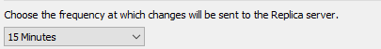

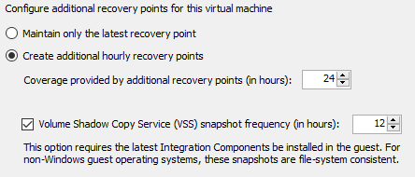

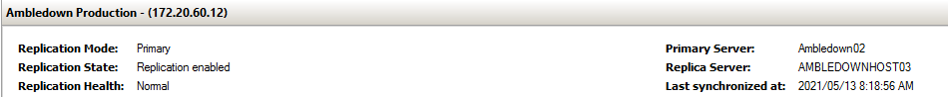

Veeam Backup and replication as Secondary Replication (Extended DR)

- On the secondary Server, there are a total of two Virtual Machines. These are replicated (extended replication) to the second Datacentre with a one hour incremental and with a total of 24 restore points.
- The second Datacentre, Paratus, is located in Windhoek, Namibia.

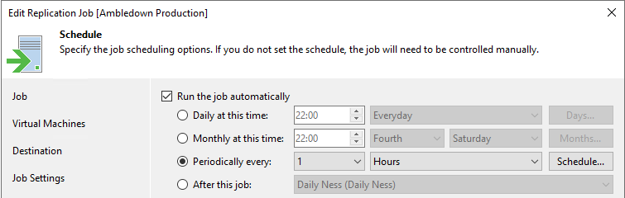

FAILOVERS

Primary Replications Failover

- Primary failover will be implemented when one of the following occurs:
- Virtual Machine failure
- Windows Updates failure (resulting in server not starting)
- Application failure
- Databases deleted / corrupted
- Primary Server failure
- Sautech will be the acting company responsible for initiating Primary Replication failover.

DR Replication Failover

- DR failover will be implemented when one of the following occurs:
- MTN Gallo Manor (Afrihost) Datacentre is completely down
- Primary and Secondary Server complete failure
- Not being able to restore the Primary Services within stipulated period of DR Policy
- Additional conditions for implementing DR failover:
- Unity Health’s DR Policy should be active and valid:
- DR failover will be implemented as per the period stipulated in the above-mentioned policy.
- Unity Health will be the acting company responsible for initiating DR Replication failover.

Backup Failover

- Backup Failover will be implemented when one of the following occurs:
- All data is missing exceeding the time frame of available Primary and DR Replications
- Data Encryption with all Primary and DR replications infected
- Unity Health will be the acting company responsible for initiating Backup Failover.

BACKUP STRATEGY

- Backup Strategy for the two Virtual Machines at the DR Datacentre:
- Daily, with a total of 30 Restore points
- Weekly, with a total of 52 Restore points
- Monthly, with a total of 12 Restore points

INFRASTRUCTURE DIAGRAM

